**Assignment 5**: Assignment and practice of AI Image Generator

**Theory:** Introduction to AI Image Generators

**1. 1. What are AI Image Generators?**

AI Image Generators are models that create images from textual descriptions using deep learning techniques. These tools can generate photorealistic, abstract, or stylized visuals based on the user's prompts.

**1.2 Popular AI Image Tools**

- DALL·E (by OpenAI)

- Midjourney

- Stable Diffusion

- Leonardo AI

- Canva AI

- Adobe Firefly

**1. 3. Applications**

- Advertising and Marketing

- Book and Game Illustration

- Content Creation

- Branding and Logo Design

- Education and Storytelling

**1.4 Limitations & Ethical Concerns**

- Difficulty with text generation inside images

- Inaccuracy in human anatomy

- Potential misuse in misinformation

- Copyright and bias issues

**Task 1:** In-Depth Comparative Research (DALL-E 3 vs. Midjourney)

A detailed evaluation of DALL-E 3 (by OpenAI) and Midjourney, two of the most popular AI image tools, is presented below.

**1. Image Quality & Realism**

**Midjourney:** Widely celebrated for its exceptional artistic and aesthetic output. Midjourney excels at generating images with sophisticated lighting, complex textures, and professional-grade composition, often resulting in a "cinematic" or "hyper-realistic" feel. Its default models are highly opinionated, meaning they apply a strong, polished artistic style even to simple prompts. This makes it a preferred tool for concept artists, illustrators, and designers seeking visually stunning, high-impact imagery. However, like many generators, it can sometimes struggle with perfect human anatomy, though its recent versions have shown significant improvement.

**DALL-E 3:** Produces extremely high-quality and coherent images with a primary focus on faithfully representing the prompt. While Midjourney pursues artistry, DALL-E 3 prioritizes clarity and accuracy. Its images are often cleaner and more illustrative. It is particularly strong at creating scenes with multiple interacting elements without the logical inconsistencies that can plague other models. This makes it ideal for producing straightforward visuals, product mockups, and illustrative content where coherence is more important than artistic flair.

**2. Prompt Accuracy & Interpretation**

**Midjourney:** Interacting with Midjourney requires a form of "prompt engineering." Users often need to structure their prompts carefully, using keywords, weighting (::), and parameters (--no to exclude elements) to guide the AI. While powerful, it can sometimes interpret prompts more thematically than literally, prioritizing the mood over specific details. For complex scenes with precise spatial relationships, achieving the desired output can require multiple iterations and refinements.

**DALL-E 3:** This is DALL-E 3's standout feature. Because it is natively integrated with a Large Language Model (ChatGPT), it possesses a sophisticated understanding of natural language, including grammar, prepositions, and nuanced descriptions. Users can write long, conversational sentences, and DALL-E 3 will interpret the relationships between objects with remarkable accuracy. It is also one of the few models that can reliably generate legible text inside images, a task that is notoriously difficult for most generators.

**3. Style Flexibility & Control**

**Midjourney:** Offers a vast range of stylistic control through dedicated parameters. Users can use commands like --style raw to reduce the default artistic bias or --stylize to control the strength of the aesthetic. It also features a specialized --niji model for generating high-quality anime and illustrative styles. The ability to blend image prompts and use commands like /describe to generate prompts from an uploaded image gives users powerful tools for deep stylistic exploration.

**DALL-E 3:** Achieves style flexibility purely through natural language. Instead of parameters, the user simply describes the desired style within the prompt itself. For example, a user could ask for an image "in the style of a medieval tapestry," "as a watercolor sketch," or "rendered as a 3D isometric model." This approach is more intuitive for beginners, though it may offer less granular control over the artistic intensity compared to Midjourney's sliders and parameters.

**4. Usability & User Experience**

**Midjourney:** The entire user experience is built around a Discord server. To generate an image, the user joins the server and types the /imagine command followed by their text prompt in a designated channel. This workflow can be unintuitive for new users unfamiliar with Discord. However, the server-based community is also a unique strength, creating a collaborative environment where users can draw inspiration from the real-time creations of others.

**DALL-E 3:** Offers a far more accessible user interface, as it is integrated directly into conversational AI platforms like ChatGPT and Microsoft Copilot. The interaction is as simple as typing a request into a chat box. A major advantage of this conversational model is the ability to iterate and refine images through follow-up requests. A user can ask the AI to "make the car red" or "change the background to a sunny day," making the creative process more fluid and interactive.

**5. Licensing, Terms & Ethical Considerations**

**Midjourney:** The licensing terms are tied to the user's subscription plan. For paid subscribers, Midjourney grants broad commercial rights, allowing them to use, sell, and merchandise the images they create. This empowers professionals in fields like advertising and branding. However, it is crucial to note that Midjourney reserves the right to use the images and prompts as well. This model raises questions related to copyright and ownership, which are significant ethical concerns in AI.

**DALL-E 3:** OpenAI's policy states that users own the images they create, providing clear terms for commercial use. This straightforward ownership model is attractive for content creators and businesses. However, like all major platforms, it operates under a strict content policy that prohibits the generation of harmful, deceptive, or violent content, as well as images of public figures. This is a direct attempt to mitigate the potential misuse of AI in generating misinformation.

**Task 2:** Expanded Visual Design Project (A Visual Story)

**Topic 1:** Create a poster for a fictional event or product

**1. Poster Concept**

Event: "Pune Futura Fest 2026"

Theme: A festival celebrating Pune's unique blend of cultural heritage and technological innovation.

**2. AI Prompt for Poster Visual**

Prompt: "Poster of Pune's Shaniwar Wada at twilight, reimagined with futuristic glowing blue bioluminescent patterns on its ancient walls. The sky has holographic data streams. In the foreground, a marigold garden with subtly glowing pixelated flowers. Style: high-tech concept art, cinematic, hopeful."

**3. Poster Text Elements**

The AI-generated image would serve as the background, with the following text overlaid in a clean, futuristic font:

Title: PUNE FUTURA FEST 2026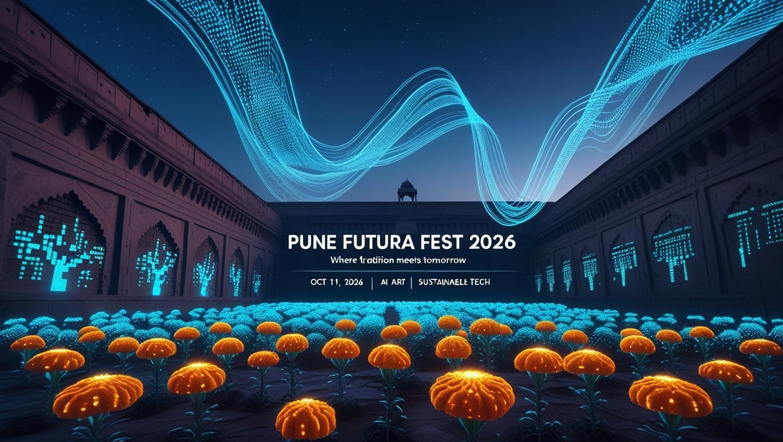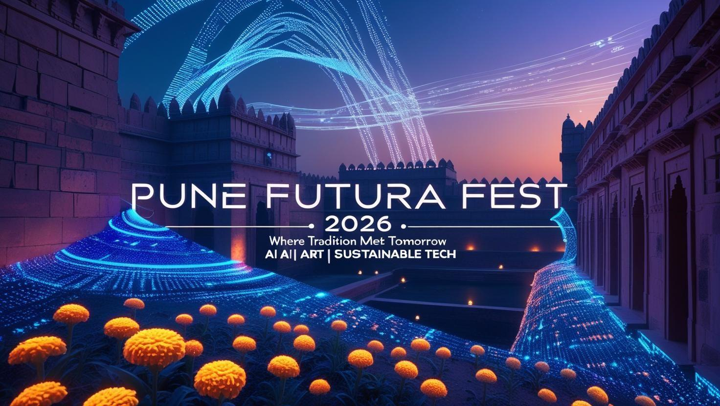

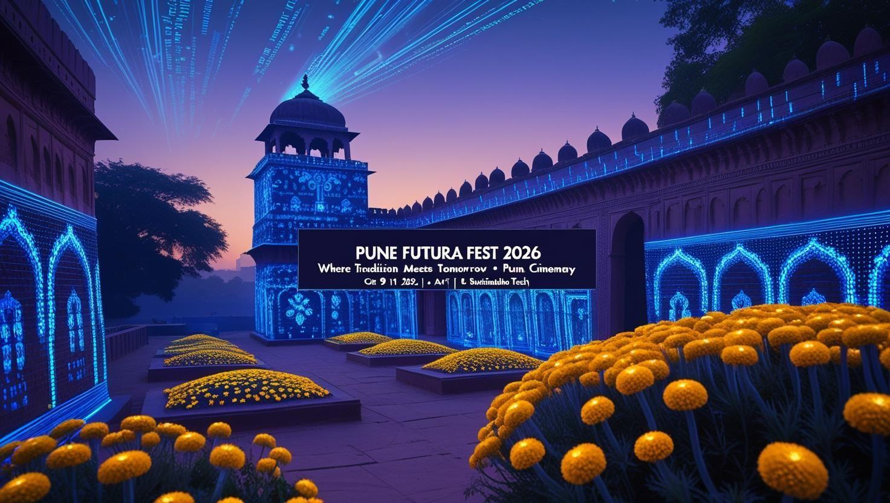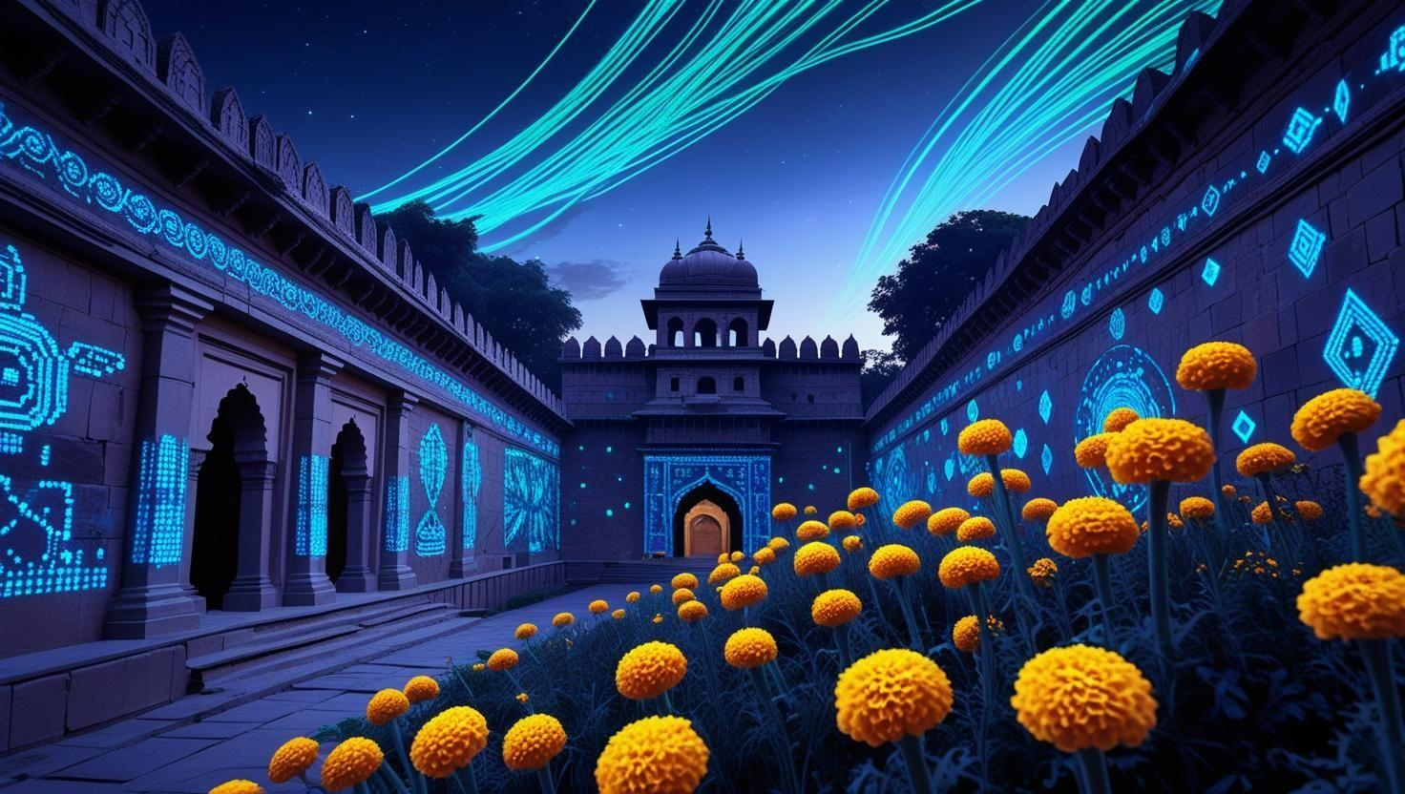

**Topic 2:** Generate concept art for an education topic,

**2. AI Prompt for Poster Visual**

Prompt: "Concept art of a 'cosmic nursery,' a nebula where new stars are being born. Swirling clouds of vibrant gas and dust in shades of pink, purple, and blue are illuminated from within by the intense light of newly-formed, massive stars. Small, rocky planets are beginning to coalesce in the foreground."